http://laughingsquid.com/a-roadmap-to-the-bay-areas-highways-in-the-sky/

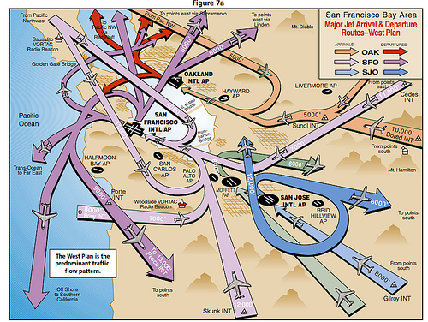

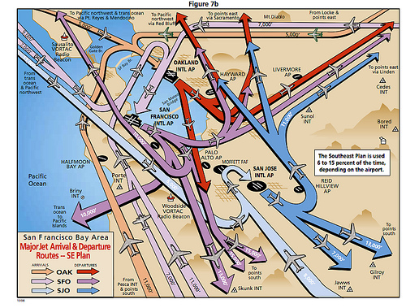

<http://airportnoiselaw.org/airspace.html>